Azure Service Bus
Resource group(move) : RgPra1ServiceBus
Active
Location : West US

Visual Studio Enterprise Subscription
Subscription ID : e08911b3-4cf8-46e9-bff9-778140b3df5e
Pricing tier : Standard
Host name : nsp-asb-demo1.servicebus.windows.net

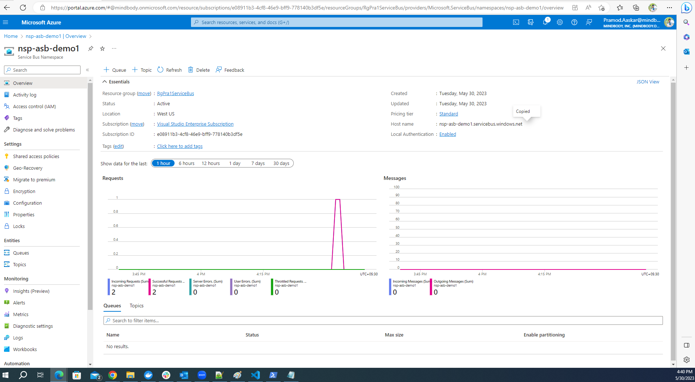

nsp-asb-demo1/servicebusqueue1

Queue : ServiceBusQueue1

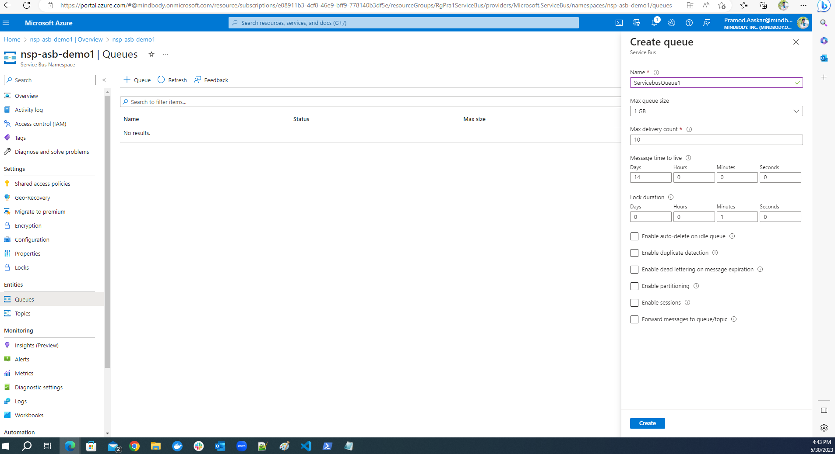

Primary connection string :
Endpoint=sb://nsp-asb-demo1.servicebus.windows.net/;SharedAccessKeyName=RootManageSharedAccessKey;SharedAccessKey=azvEXaBCjFA+ATqyghPaTLSL27ZGWgKIR+ASbJ+ztEQ=

Topic :

Namespace : ServiceBusTopicDemo2
Resource group : RgPra1ServiceBus

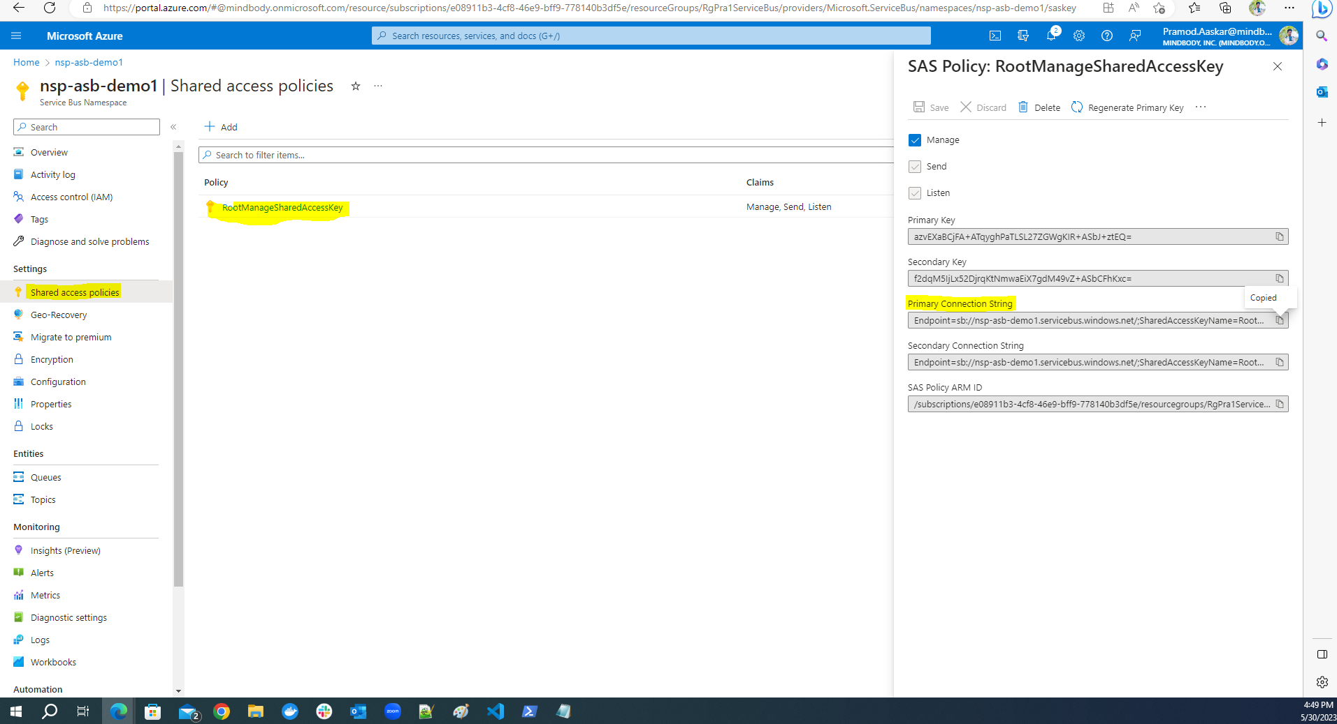

Queue Messages
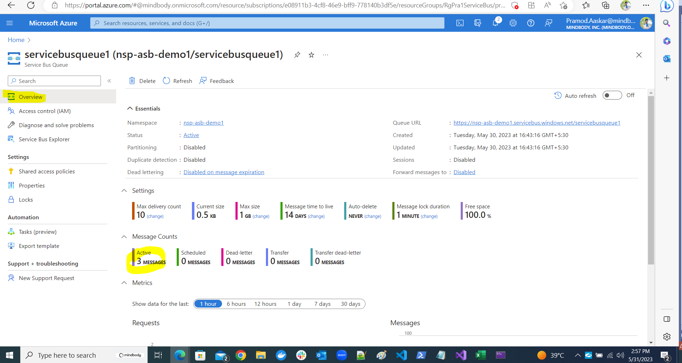

Pick Mesage from Queue
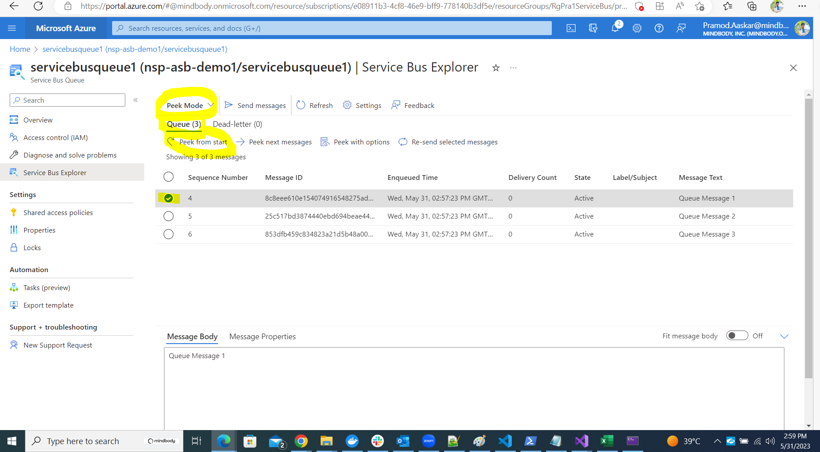

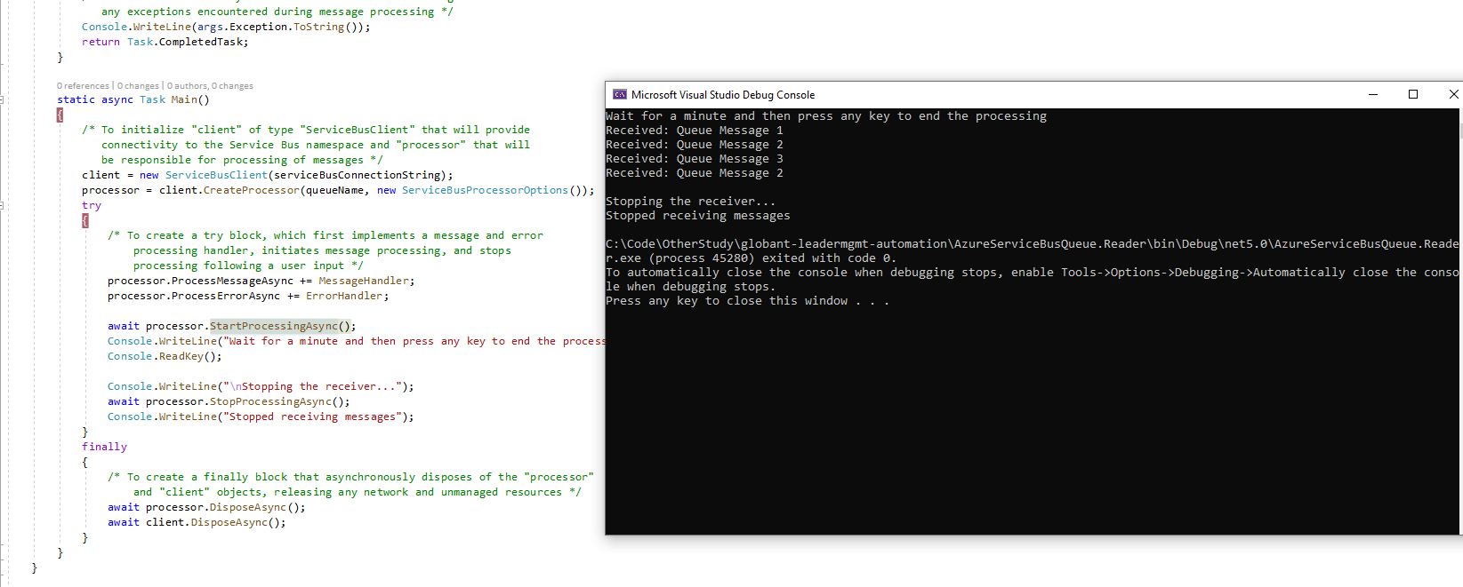

Pick Mode and Receive Mode
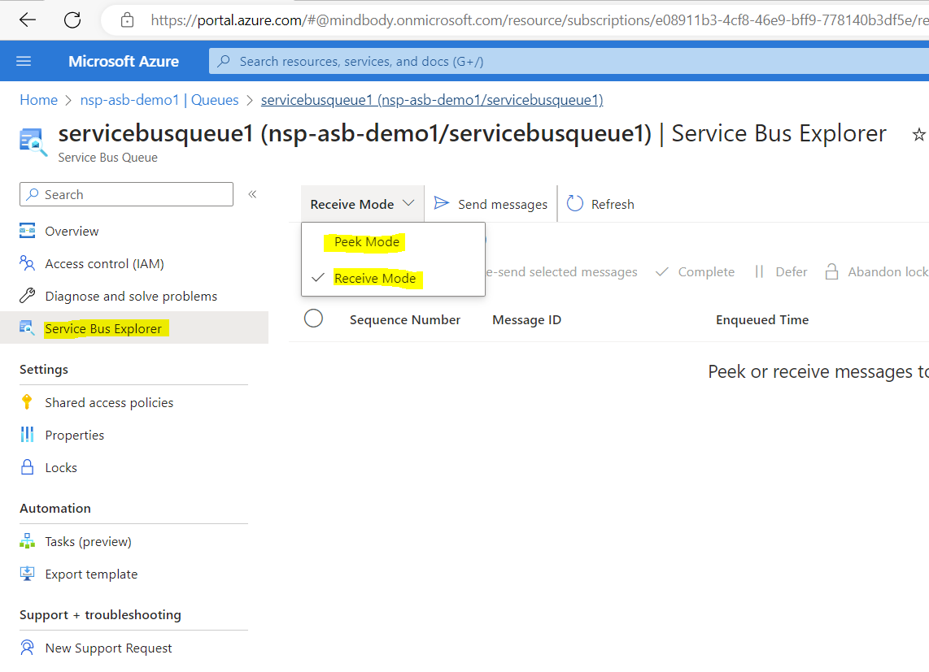

Topic:topic1
in same Service Bus Namespace

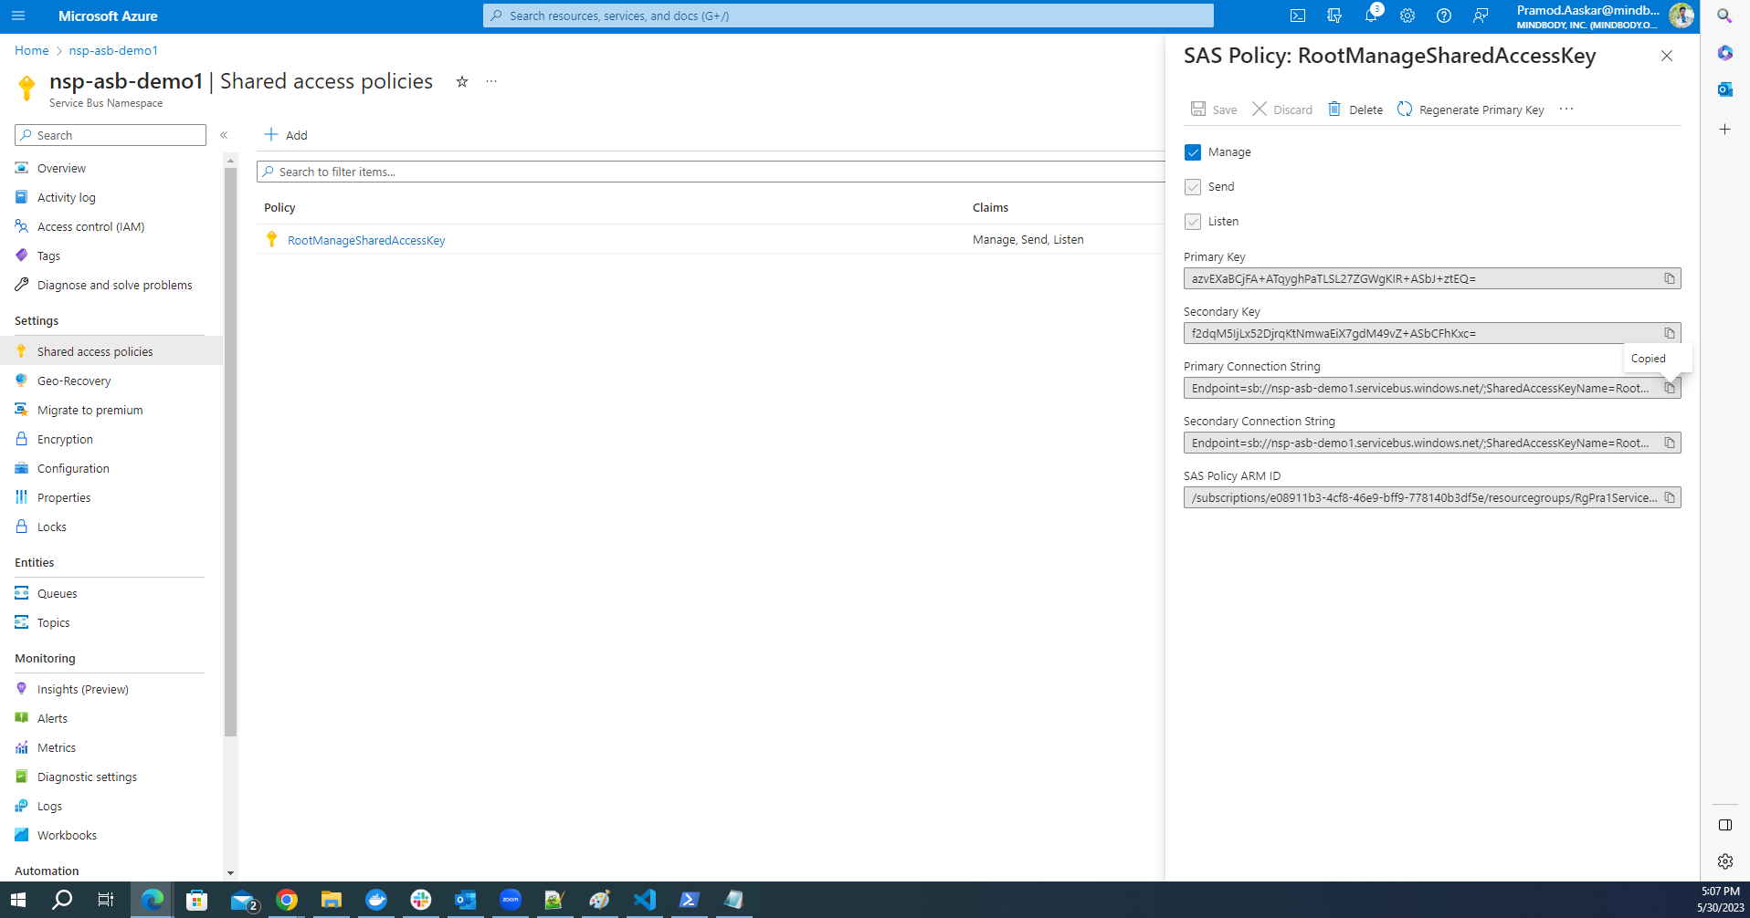

In same Service Bus namespace we have added topic1

Nsp-asb-demo1
Topic name : topic1

Subscription name : topic1sub1
Conn string : Endpoint=sb://nsp-asb-demo1.servicebus.windows.net/;SharedAccessKeyName=RootManageSharedAccessKey;SharedAccessKey=azvEXaBCjFA+ATqyghPaTLSL27ZGWgKIR+ASbJ+ztEQ=

Subscription : topic1sub1 and topic1sub2

